Energy requirement modelling for AGV, considering material and layout data
In the experiment, two types of industrial mobile robots were used. The system’s components that require energy were classified, and their power consumptions were measured individually.
Parameters: vehicle speed, load-handling duration, load, utilization, material flow, layout data, and charging infrastructure system frequency.
The paper considers the state-based energy requirement model with various influencing factors on the AGVs. The model can be used for different vehicle types and transport layouts.
Parameters of transport layout, transport orders, utilization, speed, charging system distribution, load-handling time, charging strategy, and the operating time were varied.
A discrete-time simulation model was developed in Java that can be used to simulate real experiments. In addition to the ERM, a simulation model consists of functional modules such as a dispatcher, which distributes transport orders to the AGV being simulated. The energy requirement can be calculated during simulation by integrating power requirement parameters over time.
The paper by Hamdy presents a simulation model to determine the optimal number of vehicles considering energy constraints. The state-based simulation model features the states blocking, traveling empty, traveling loaded, accelerating empty, accelerating loaded, decelerating empty, decelerating loaded, picking and dropping, whereby each has a constant total power.
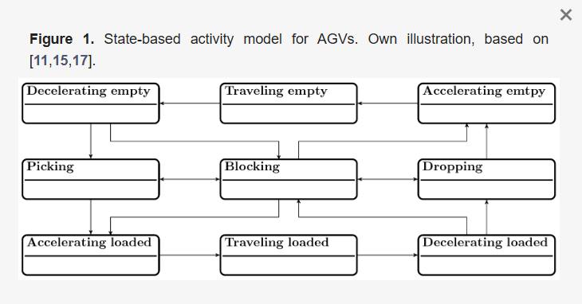
The work by Meissner, Massalski experiments with the electric power of the drives of the AGV with differential drives were meased and analyzed for procedure. In a state based simulation model, the states accelerating, driving, and decelerating were represented and reported a relative average deviation in the energy requirements of the drives as
Δ𝐸=−5.59%. In experiments, the driving speed and the transported load were varied. Through performance measurements of the LHD and data analysis, five active sub-states could be identified. These are the acceleration of the LHD, lifting without load, lifting load absorption (where the lifting load increases), lifting under full load, and breaking.
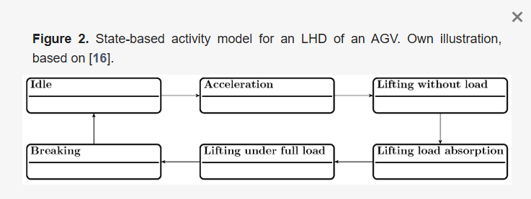
The relative deviation in the energy consumption modeling of the load-handling device was stated as Δ𝐸=−7.1%. The findings on energy consumption were processed quantitatively and show that the power does not vary linearly with increasing speed and transport weight. The correlation resulting from the investigations can be further transferred into a nonlinear optimization problem in order to determine an optimum operating point with minimum energy consumption.
Operating and charging strategies. Charging states of the vehicles and the utilization rate of the charging systems impact the behavior regulation of the AGVs. The three most common charging strategies are the capacitive operation (capacitive), the capacitive operation with intermediate charging (interim), and the opportunity charging (opportunity) .
Dispatching. systematic distribution of transport orders to the vehicles of a transport system. Whereas, in centralized allocation, a fleet manager has information about the utilization of the vehicles and distributes the orders strategically, in decentralized allocation, the orders are negotiated between the vehicles and distributed.
Modeling Energy Storage Systems (ESSs). In AGV systems, lead–acid ESSs are still widely used. Even the latest guideline VDI 2510 part 4 [25] still includes parameters for the design of lead–acid ESSs for AGVs. The most typical ESSs are lithium cobalt oxide (LCO), although other types of lithium-based ESSs are frequently used in AGVs due to their low specific energy density. The characteristics (cf. Table A6) show that the cell voltages and the C-rates, as well as the maximum voltage strokes, vary strongly for the ESS. Another type of energy storage is the electronic double-layer capacitor (EDLC). This term describes capacitors with extended capacity compared to electrolytic capacitors. Unlike electrochemical ESSs, the electrical energy is stored by an electric field. An EDLC has a capacitance of 1 F1 F to over 6000 F6000 F at typically 2.7 V2.7 V to 3.0 V3.0 V per cell.
Material flow system description. The transport orders and distance relationships are modelled in the form of matrices, whereas 𝐴TAT describes the transport matrix of a composition and 𝐴DAD the distance matrix.

Energy modelling:
Step 1: Components of an AGV that require energy
Step 2: The power requirement for the respective components should be defined with its influencing factors.
Step 3: The total energy requirement is determined by summing up the power requirements of the components over time.

Step 1 : System Components
Drives, controls, load handling device
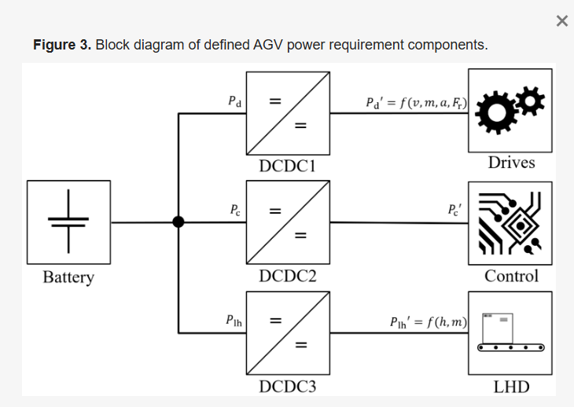
Drives include the electrical power of the drives and motor controls as a function of velocity, acceleration, and the weight of the load being transported. All remaining parameters, such as slip, expressed as friction force, are considered in the linear power requirement approximation.
Motor controllers or regulators are also part of this power requirement component. Controls include all components that are responsible for control, communication, navigation, and localization, as well as system safety. This includes, for example, lighting equipment, safety controls, and safety sensors.
The LHD includes all components that are involved in the load-handling process. These include lifting or transfer drives and hydraulic pumps, as well as associated control, communication, and sensor units.
For each power requirement component, DC-DC converters (DCDCs) are connected in series to regulate the voltage level between an energy storage system and the system components. The efficiency of the DCDCs 𝜇DCDC is typically described as a function of the output current
Step 2:
From these previous studies, the process states of acceleration without load, acceleration with load, drive without load, drive with load, deceleration with load, deceleration without load, pickup, deliver, and standby can be derived. Standby summarizes the processes of waiting, blocking, and idle. In the course of a qualitative process analysis, in which 25 different AGVs were examined, it was found that, in addition to previously identified states, four additional states are required in order to develop a holistic description model. These are Prepare docking, Dock, undock, and Prepare driving. Prepare docking includes waiting times for process calculation and initialization of the LHD for Dock. Similarly, Prepare driving includes process calculation waiting times and initialization of the LHD for driving. The initialization for driving includes substates that bring the vehicle into a state ready for driving. These include, for example, lowering the LHD to a defined transport height.
Step 3:
The literature review presented in Section 2.1 shows that speed, acceleration, weight of the load, and movement direction φ have a significant impact on the electrical power requirement of the drives. Another impact on the power requirement of the controls is ambient temperature. Cebrian and Natvig [46] stated that the power requirement of processors is highly temperature dependent. Finally, the weight of the load has a significant impact on the power requirement of the LHD (cf. Table 1, [16]). Eggers et al. [47] analyzed the impact of temperature on the power requirement of industrial robots. They found that increasing temperature reduces the friction force in the joints and thus decreases the total power requirement. The same could apply for LHDs of AGVs but this is not considered further in this work.
Linear power approximation:
To model the power requirement of the drives, the functional relations between mass, velocity, acceleration, deceleration, and the movement direction 𝜑φ are simplified by linear approximation. The power requirements of the individual system components are assigned to different states
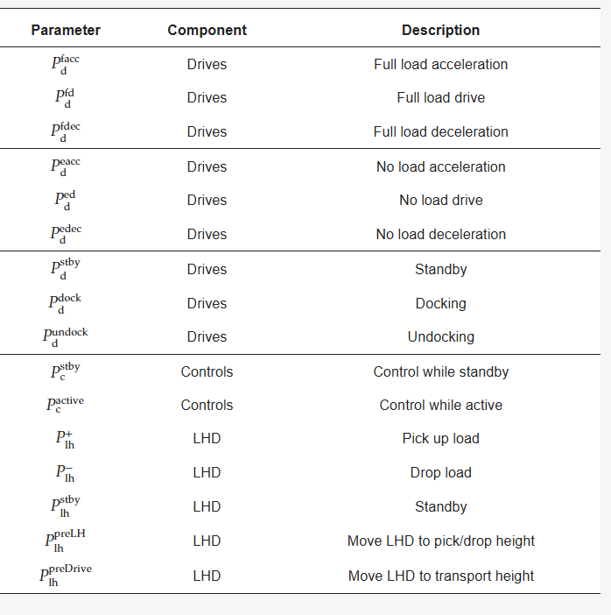
Energy Requirement Model (ERM)
Based on the identification of the system components with a power requirement (a process analysis , a power requirement impact analysis , a resulting linear power requirement approximation , and a holistic state-based model were elaborated as shown in Therefore, the ERM can approximate the power requirement of different AGVs.
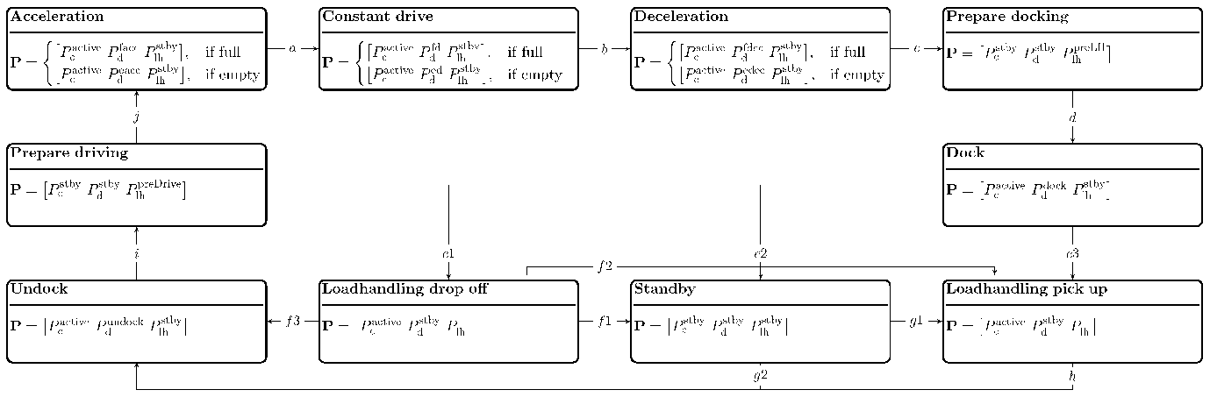
shows 10 different states describing the previously mentioned process states of an AGV, each containing a vector 𝐏P, including the individual mean power requirements:
𝐏= [𝑃ctrl 𝑃drives 𝑃lh]
The arrows connecting the states describe the possible linkage of states to an overall process. The initial state is standby. After standby, either a run can be started via states Undock (g2), Prepare driving (i), and Acceleration (j), or a load can be picked up at the current position (Loadhandling pick up via g1). If the vehicle is in Acceleration state, then state Constant drive is achieved after reaching the target velocity 𝑣max (a). With the initiation of a braking process at the end of a run, Deceleration (b) becomes active. After stopping, the next states Prepare docking and Dock become active in sequence. After reaching standstill again, three states are possible: Loadhandling pick up via (e3), Loadhandling drop off via (e1), or Standby via (e2). Standby can be reached if waiting times are required due to interruptions in the operating flow. If the AGV is in Loadhandling drop off state, Standby (f1), Loadhandling pick up (f2), or Undock (f3) state is reachable accordingly. From Standby state, either Undock (g2) can be initiated directly or a load can be picked up (Loadhandling pick up via g1).
Total Energy Requirement Approximation.
As a result of the impact analysis (cf. Section 3.3), the distance is not sufficient for the approximation of the total energy requirement of AGVs. To approximate the total energy requirement of an AGV in operation more accurately, data of the actual material flow and layout are required. However, the linear power requirement approximation of the AGV must already be completed and the power characteristics must be known. In order to determine the partial energy requirements of AGVs in the respective states according to Figure 4, the average durations 𝑡state,𝑖tstate,i of the corresponding process states i are required. Starting at a nominal time t0, the power vector 𝐏 will be integrated until 𝑡0+𝑡state,𝑖t0+tstate,i, mathematically formulated as follows:
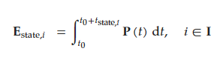
𝐈 describes a set of all states that are within an evaluation period t. Considering 𝑣max, 𝑎acc, 𝑎dec, and the current transport distance 𝑑𝑗, 𝑡Drive,𝑖 it can be determined as follows:
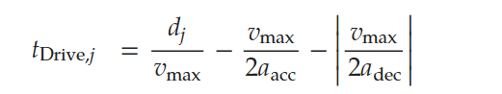
The total scalar energy requirement 𝐸(𝑡) is the sum of all individual states as a function of 𝐴T, 𝐴D, the evaluation period t, and the dispatching method used. Mathematically, this is formulated as follows:
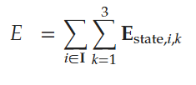
CHARGING-
According to the charging characteristics of valve-regulated lead-acid battery, the duration of each charging occurrence was reduced to get more working time. The paper used to study proposed two stages of battery charging strategy, which include selection of route and selection of charging duration.
Stage 1: Reduce the routing time and travelling time of AGVs
Stage 2: Duration of charging time is selected to reduce the waiting time of the charging process.
Stage 1: selection of nearest charging station(NCS):
After the AGV has finished the job, the available charge is checked to determine is less than a threshold. When charging is required, it travels to the nearest charging station for automatic charging.
OR
Selection of minimum delay charging station(MCDS): when the amount of AGVs is greater at charging stations, it may happen that the AGVs are queued, such situations cause more waiting time to reduce the utilization of AGVs. The minimum delay charging station means that the AGV consumes minimum time considering waiting time.
Stage 2: Selecting charging duration
The lithium-ion batteries have faster charging times and lighter weight than the valve-regulated lead-acid batteries. The charging process of the lithium-ion battery can be divided into two stages: 1) constant current charging, 2) constant current voltage charging.
Charge time and battery capacity present a nonlinear relationship, the charging efficiency is higher in the initial stage. AGVs will obtain more time to productive by reducing the duration of each charging occurrence. Therefore, in the case of the same number of AGVs, the factory would have the possibility of yielding more output.
The time required for recharging depends on its depth of discharge (DoD), which refers to the percentage of battery discharge and its full capacity. Another concept regarding charging time for lithium-ion batteries is the state of charge(SoC), which means the percentage of charge remaining and its full capacity. DoD+SoC=100%, according to Mejdoubi el at. [10], the battery should not have more than 80% DoD.
In order to saving time, the charging duration was reduced to recharge the battery to a lower SoC level in the short term. According to Qazi el at. [11], 3 target SoCs were determined, namely 100% SoC, 95% SoC and 90% SoC.
To further obtains the relationship between DoD and charge time, the regression technique is used to fit the data. According to the result, three fitted equations are got where x indicates DoD and y means charging time. Eqs. (1)-(3) represent the regression formulas for 100% SoC, 95% SoC, and 90% SoC respectively. Meanwhile, it can be found that the value of coefficient of determination (R2 ) for all three equations is greater than 0.98, which indicates the precision of the results.
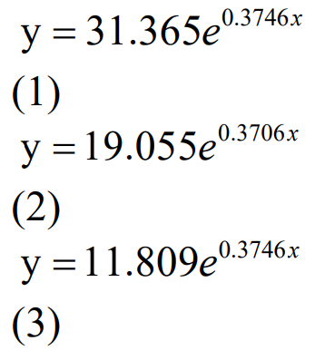
Step 1: If the remaining charge of the empty AGV is less than the pre-specified trigger level charge, go to step 2. Otherwise, go to step 8.
Step 2: Select the battery charging strategy of NCS, go to step 3. Select the strategy of MDCS, go to step 4.
Step 3: The AGV moves to the nearest charging station from its current (outlet or loading point). If select 100% SoC, go to step 5, if select 95% SoC, go to step 5; otherwise, go to step 6.
Step 4: The AGV moves to the charging station with minimum time for waiting in line and travelling from its current location. If select 100% SoC, go to step 5, if select 95% SoC, go to step 5; otherwise, go to step 6.
Step 5: Set the charging duration to ensure the state of charge is 100% at the end of charging, then go to step 8.
Step 6: Set the charging duration to ensure the state of charge is 95% at the end of charging, then go to step 8.
Step 7: Set the charging duration to ensure the state of charge is 90% at the end of charging, then go to step 8.
Step 8: The AGV returns to the parking area and receives a new job.
The pre-specified trigger level charge in this study is 23% to ensure the residual capacity of the depleted battery goes not less than 20% after completing a new job. As shown in Fig. 3, the flow chart shows the two dual-stage charging strategies.
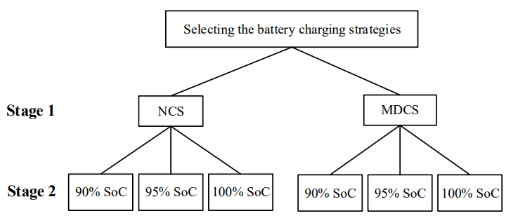
DISPATCHING –
Dispatching refers to the selection and assignment of work to AGVs. In general, the dispatching rules are divided into two types of operation decisions: 1) workstation-initiated and 2) vehicle-initiated, depending on whether the system has idle vehicles (vehicle-initiated) or queued transportation requests (workcenter-initiated). The vehicle-initiated dispatching determines the load to be assigned to a vehicle when the vehicle is ready for the next task, whereas the workcenter-initiated508 K.C.T. Vivaldini et al. dispatching determines the vehicle to be selected when loads initiate transportation requests.
The common objectives are minimization of load waiting time, maximization of the system throughput, minimization of queue length, and guarantee of a certain service level at stations.
Scheduling defines the allocation process of AGVs for tasks, considering the time and cost operations [12] and guaranteeing conflict-free routes. The main goal of most scheduling problems is to transport loads (products, pallets or containers) as quickly as possible to satisfy time window constraints. Other criteria can be the minimization of the maximum load waiting time and the maximum number of items in critical queues.
Scheduling can be divided into two key factors: is a predictive mechanism that determines the planned start and completion time of labor operations and a reactive mechanism that monitors the progress of the schedule and deals with unexpected events (failures, breakdowns, cancellations, date changes, etc.) [13].
The main approaches are dispatching rules, metaheuristics, and integer/mixed programming. Using dispatching rules, Hwang and Kim [25] proposed a new task dispatching algorithm for AGVs based on restrictive rules. The information from the WIP (WorkIn-Progress) and the travel time of AGVs (considered deterministic) is used for the algorithm operation. The proposed solution divides the problem of allocating a task to an AGV into a combination of 3 functions.
The first takes into account the distance from a vehicle to the workstation and requests the execution of a task transportation; the other two functions weigh the urgency of that task execution, taking into account the state of the input buffer of the destination station and the output buffer of the station that requests the transportation.
Routing –
Vehicle Routing refers to the process of determining one or more paths or sequences of path to be performed by a fleet of vehicles. The purpose is to visit a set of nodes geographically dispersed in predetermined locations that must be attended. They are classified into two categories: static routing algorithms and dynamic routing algorithms.
In static routing, all data are known prior to the calculation of the route and do not change during its execution. The route is calculated without taking into account collision avoidance, which can dramatically affect the system performance due to possible deadlocks.
To solve traffic jams and congestion of AGVs, the development of conflict-free routes has emerged in the literature. Broadbent et al. [41] introduced the first concept of conflict-free and shortest-time AGV routing. The routing procedure described employs Dijkstra’s shortest path algorithm for the generation of a matrix, which describes the path occupation time of vehicles. Krishnamurthy, Batta and Karwan [42] developed a column generation method for the static routing problem in which an AGV has to move in a bidirectional conflict-free network and minimize the makespan.
We use column generation method, where Each column represents a valid, conflict-free route for an AGV. The RMP selects a set of routes (one per AGV) that minimize the makespan. The pricing problem generates new feasible routes that are conflict-free and potentially better. This avoids generating all possible AGV routes up front (which would be computationally infeasible).

Designing Energy storage system with PEMFC stack-

The paper designs a power supply system simulation model focusing on selecting correct parameters for the hybrid energy buffering system, to minimize vehicles downtime, The model-based design (MBD) methodology is used in the design and construction of a complete simulation model for the system, which consists of the fuel cell system, energy processing, a storage system, and an energy demand model.
Model-based design (MBD) methodology is often used to design complex mechatronic systems [1,2]. The methodology consists of building computer simulation models of the designed system and simulating its operation. s. In our case, the system crosses fields that include mechanical, electrical, and chemical sciences, which address difficult to describe phenomena and require personalized and very specific system control
Usually, the complete model includes not only the designed system, the power supply system, and the drive system, but also the entire facility on which the designed system is built, as well as external conditions affecting the operation of the whole. e. For vehicles, this is usually a power system model, the propulsion system model, and the entire vehicle model, and often includes the route model and the conditions they encounter
Usually, choosing the correct system parameters makes the most sense when the vehicle is traveling along a fixed route or a finite and known set of routes where the load and driving conditions are set or predictable. With this knowledge, one can accurately determine the features of the power system. This is the case with certain types of vehicles such as AGVs or racing vehicles. However, if the load conditions and route conditions are unknown or difficult to predict, the task is much more difficult, and the results will not be as definitive as expected.
Irreversibles
Definition: Irreversibles refer to losses that occur during the operation of a fuel cell, which prevent it from achieving its theoretical maximum efficiency. These losses lead to a voltage drop compared to the ideal voltage predicted by the chemical reactions occurring in the fuel cell.
Types of Irreversibles:
Activation Losses: Energy lost due to the time it takes for the electrochemical reactions to start.
Fuel Crossover and Internal Currents: Losses due to hydrogen crossing over to the oxygen side of the cell and internal currents that do not contribute to power generation.
Ohmic Losses: Resistance to the flow of electricity within the fuel cell components.
Mass Transport Losses: Losses due to the difficulty of getting reactants (hydrogen and oxygen) to the reaction sites.
Concentration Losses: Losses that occur when the concentration of reactants at the reaction sites decreases, affecting the reaction rate.
If the power take-off is not variable, this system may be simpler, but with high variability of energy demand, it is necessary to consider the electric converter/inverter and energy buffer supplied via batteries or supercapacitors. Supervising the work of these devices can take place at various levels, most often at the basic level through ongoing control of the parameters of individual devices, and frequently at the strategic level by adapting the operating parameters not only to the ongoing demand but also to future demand.
Conducting simulation experiments requires the definition of the HPS system in the AGV. Since these vehicles are designed for close repetitive transport operations over long periods and have known operating conditions, i.e., speed and load, one can adapt the HPS system to individual needs, such as the demand for instantaneous power during a specific operating condition. At this stage, the criterion for assessing the designed HPS system should also be determined. For the next step, it is necessary to measure and identify the instantaneous power demand by the AGV at different operating conditions. These measurements should include the power demand for expected operating conditions over the planned route. From this, work can be completed on the data preprocessing, modeling, and validation of the models representing the power demand. These models are identified based on data from instantaneous power measurements at various operating conditions. Based on a set of such models, it is possible to simulate the power demand for the new AGV route and other operating conditions.
Simultaneously, by the defining power demand models, it is possible to create component models of the HPS system. It should be noted that these models of HPS can be identified based on additional measurements or characteristics provided by the manufacturers. More information about creating and identifying component models of an HPS including a hydrogen cell, models of storage components, and other auxiliary components, are described in Section 3.2. To validate the hybrid power supply system model, it is possible to provide the load in the form of played-back real values of instantaneous power demand and creating comparisons, e.g., concerning the current power supply system installed in AGV

https://www.sciencedirect.com/journal/transportation-research-part-c-emerging-technologies
https://ieeexplore.ieee.org/xpl/RecentIssue.jsp?punumber=6979

